Subject of risk assessment: | Tree Climbing and Climbing Obstacles
Brief description of activity, location, feature, activity and equipment used. | Climbing of trees with participants (adults and children)  Climbing of obstacles such as logs, boulders, walls, fences, gates, shrubs etc.
Type of assessment  (if play design process) | Designer | Provider |  |  | Post Installation Monitoring
Job title and name of person making assessment | Matt Robinson |  | Signature of person making assessment
Date of Assessment | 12 December 2023 |  | Review Date | 1st January 2025
Name of senior manager: | Carley Sefton |  | Signature of senior manager:
Risk Management Statement
LtL recognises that all risks cannot be reduced to nil, therefore this risk assessment prioritises the significant risks. Significant risks are those which pose risk of serious injury, chronic injury, disability or death, or risks that are overly common in interrupting our staff and clients normal work.

For all activities, LtL staff will dynamically assesses risks and put in place control measures and record as required, but always within agreed and recorded RBA’s.

Concerns, changes in risk management practice or minor injuries that are seen by LtL staff to be significant should be reported to the LtL manager who has signed off this RBA.

This RBA should be read in conjunction with LtL’s Health and Safety Policy, other relevant LtL Risk Benefit Assessments and LtL Play Policy (as appropriate).

Activity or feature: | Climbing tree in woodland, forests, parks and playgrounds.  Climbing a variety of obstacles such as walls, boulders and logs.  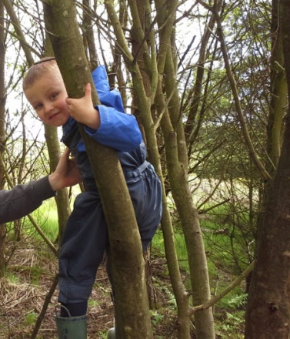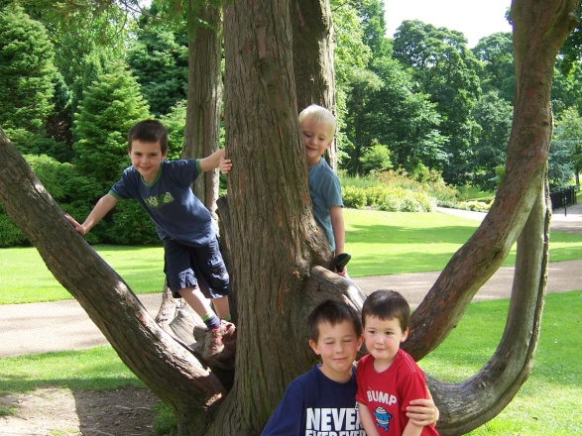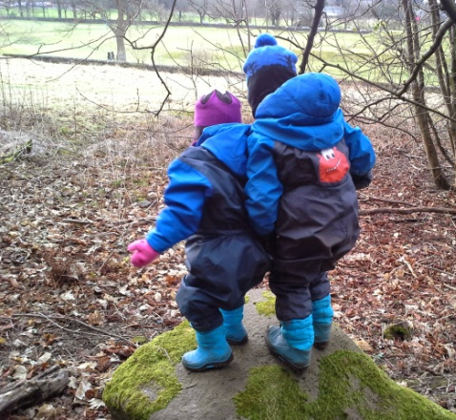
How will participants benefit? | Learning to make risk judgements and manage risk.  Balance, co-ordination, strength and general physical literacy will be developed. Developing confidence through awareness of physical capabilities.  Group working and social skills will be developed by participants, including turn taking and socially supporting each other verbally.  Learn about tree types and properties (strength, flexibility and rooting)  Engagement with natural environment.  Builds resilience and then confidence through success and challenge.  Fun, achievement and physical enjoyment of the activity.
Who will be at risk? | LtL Staff  Participants (Adult and children)  Public
Any local factors that may affect risks or controls: | Group competence, local school or authority rules.  Weather conditions, particularly cold and ice, assessment made ‘on the ground’.
Possible hazards and risks: | Falls to ground or onto objects, resulting in serious injury either through contact with tree on the way down or impact with the ground.  Strangulation from the rope.  Becoming ‘hung up’ by feet or limbs, leading to injury.  Participants falling on each other or being kicked accidently while below climbing activity.
Precautions and control measures to reduce the risk severity or likelihood: | Careful selection of climbing site and area by LtL staff. This will be informed by tree type and condition, ground conditions. For non-tree climbing, this will be informed by construction, ground type and fall hazards. A dynamic risk assessment by the staff on the day. Smaller trees will be selected, reducing possibility of excessive height being gained. Beech trees will not be used. LtL Staff members will check branches or trees as weight bearing before a group starts.  The ground around the climbing area should be clear of hazards such as sharp edges and objects, significant differences in surface (e.g. an edge from concrete to grass) should also be regarded with caution. LtL staff may move objects as required.  Good group briefing and control from LtL staff, supervision of tree climbing by responsible adult at all times, although with group competence this may become more subtle.  Ground rules used at all times are:  - Participants only climb what they choose to do, with no external physical support (e.g. from adult or ladder) or peer pressure.  - Participants only climb what they can down-climb.  - Participants will not be helped down, only spotted for falls.  - Participants will usually only climb to a distance of their own height from the ground. With the provision of a suitable surface (e.g. woodchip, pine needles, gravel or soft earth without objects) and judgement the climbing height may be increased to twice the height of the participant, or the height of the LtL staff member (whichever is less).  Notice of current and forecast conditions will be taken, with a view on how wind will affect the site.  All LtL staff leading sessions will hold a relevant emergency first aid qualification, appropriate to the training being led, and carry a first aid kit.
Precedents or comparisons: | Association of Play Industries – Provision of Impact Absorbing Surfaces guidance has been incorporated into our Risk Benefit Assessment.  Rope Swings, Tree Houses and Dens – Forestry Commission is clear about fall heights when climbing or swinging, up to 2m, and the ground conditions judgements.
Judgement: | Tree climbing is an enjoyable, memorable, confidence building activity that can develop physical literacy and risk management skills in all ages.  The risks posed are manageable when related to the competence of the group, simple ground rules, and an LtL staff member who makes good judgement and has good group management.  Tree climbing should be used with all ages as part of LtL’s work.

