Subject of risk assessment: | Rope Play
Brief description of activity, location, feature, activity and equipment used. | Rope swings (set up by LtL staff or participants)  Rope bridges (set up by LtL staff or participants, including slack lines, postman’s walk and similar).  Rope play, including holding up dens and structures or helping climb steep slopes.  Typically this is in woodland (school playground or public access), although it may also be using constructed equipment such as in a play park.
Type of assessment  (if play design process) | Designer | Provider |  |  | Post Installation Monitoring
Job title and name of person making assessment | Matt Robinson |  | Signature of person making assessment
Date of Assessment | 12 December 2023 |  | Review Date | 1st January 2024
Name of senior manager: | Carley Sefton |  | Signature of senior manager:
Risk Management Statement
LtL recognises that all risks cannot be reduced to nil, therefore this risk assessment prioritises the significant risks. Significant risks are those which pose risk of serious injury, chronic injury, disability or death, or risks that are overly common in interrupting our staff and clients normal work. For all activities, LtL staff will dynamically assesses risks and put in place control measures and record as required, but always within agreed and recorded RBAs.

Concerns, changes in risk management practice or minor injuries that are seen by LtL staff to be significant should be reported to the LtL manager who has signed off this RBA. The correct LtL Incident Report form should be used.

This RBA should be read in conjunction with LtL’s Health and Safety Policy, other relevant LtL Risk Benefit Assessments and LtL Play Policy (as appropriate). (as appropriate).

Activity or feature: | Pictures as example.  Temporary rope swings set up by LtL staff or participants, using ropes supplied by LtL, and temporary seats from knots, branches or sections of timber.  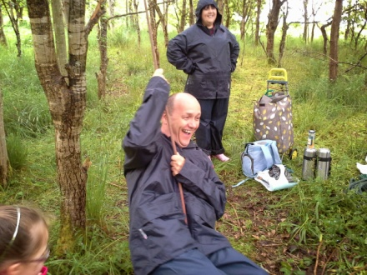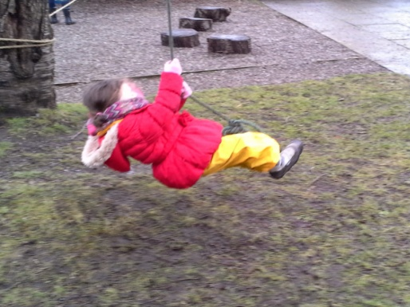  Rope bridges (set up by LtL staff or participants, including slack lines, postman’s walk and similar), using ropes supplied by LtL.  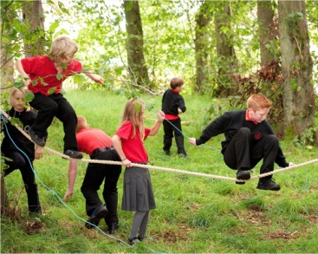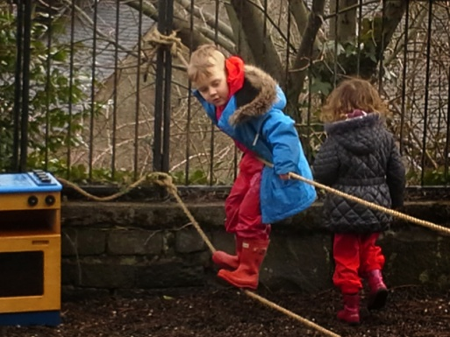  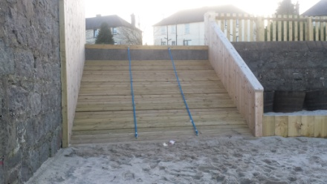  Rope play, including holding up dens and structures or helping climb steep slopes.  Hammocks are typically attached to trees or posts, close to the floor. They may be temporary or permanent, net or fabric.  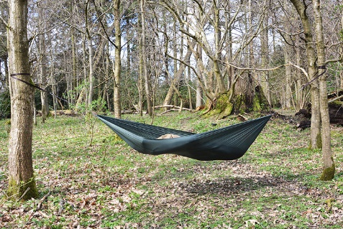  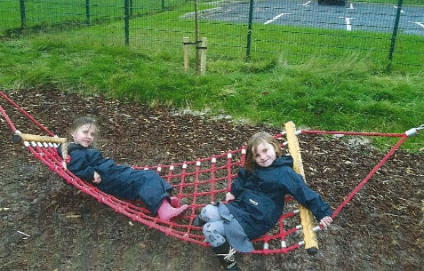
How will participants benefit? | Learning to make risk judgements and manage risk for themselves.  Balance, co-ordination and general physical literacy will be developed by constructing and then using simple rope activities.  Group working and social skills will be developed by participants, including turn taking and socially supporting each other.  Learn about materials (strength, flexibility, knot tying etc) and tree types (strength, flexibility and rooting)  Engagement with natural environment.  Builds resilience and then confidence through success and challenge.  Fun, achievement and physical enjoyment of the activity.
Who will be at risk? | LtL Staff  Participants (children and adults)  Members of the public
Any local factors that may affect risks or controls: | Group competence, local school or authority guidelines.  Conservation areas / protected trees / protected fauna such as Bluebells.
Possible hazards and risks: | The rope or seat may snap or knot fail, dropping person(s) to the ground from too high, leading to significant injury.  The branch or tree may snap, bend or uproot, dropping the person(s) on to the ground from too high leading to significant injury. The tree or branch may also fall on the person(s) when this occurs as well, leading to significant injury or death.  Hammocks may also fail – either knots coming undone, or damage to the ropes or material ripping. They can also tip up violently, dropping occupants to the floor. Both these leading to significant injury if the fall is from height, or onto sharp or hard objects, or is very sudden/violent.  Falls to the floor, onto sharp, hard or protruding items that leads to significant injury.  Other participants or public could collide with swinging Participant. Swinging participant could collide with tree(s), leading to serious injury if hard enough.  Participants may walk into attached ropes, leading to injury through contact with rope or sudden trip or upending.  Participants could hang from the rope in a way that injures them seriously – damage to limb by wrapping rope around, or strangulation of neck.
Precautions and control measures to reduce the risk severity or likelihood: | Rope swings:  - Will be constructed by LtL staff and Participants, with the LtL staff member undertaking a Dynamic Risk Assessment of the tree, the rope and attachment (knot) and immediate surroundings such as floor and obstacles.  - The LtL staff member will test any new obstacle first  - Participants feet on rope swings will be under the head height of the Participants at maximum swing/elevation.  - Good group briefing and management by LtL staff, including teaching to step off not fall off and vigilance for others entering swing area or overly zealous swinging.  - Vigilance and zero tolerance of wrapping the rope around any part of the body.  Rope bridges, including slack line:  - Will be constructed by LtL staff and Participants, with the LtL staff member undertaking a Dynamic Risk Assessment of the trees, the ropes and attachments (knots) and immediate surroundings such as floor and obstacles.  - The rope bridges will be lower than the height of the Participants heads, and typically will be much lower around ankle to hip height.  - Ropes will be tight enough to prevent wrapping around body parts, even in the event of a fall.  - Good group briefing and management by LtL staff, including teaching to step off not fall off and vigilance for others getting too close or walking through area.  Ropes to support climbing  - Will be constructed by LtL staff and participants, with the LtL staff member undertaking a Dynamic Risk Assessment of the trees, the ropes and attachments (knots) and immediate surroundings such as floor and obstacles (particularly at bottom of a slope).  - Particular care to be taken if the ropes are loose ended and vigilance to prevent rope being wrapped around any part of the body.  Ropes & hammocks  - Hammocks will be no higher than the group’s average height or the height from which the LtL staff member is happy for them to fall (whichever is the lower).  - Hammocks should be placed off paths and above ground that has been checked for sharp, hard or awkward objects to fall on.  - Knots used should be good enough to hold or ease slowly (no-knot knot for example).  In all situations LtL staff will match group competence (not confidence) with the level of difficulty and risk that any rope play poses, particularly with regard fall height and swing speeds.  At no point will participants be helped by LtL staff or other participants onto such equipment, further limiting heights. Small, natural materials may be used as steps on, but not ladders or above head height of the participants.  Any ropes used for such play will be visually inspected by LtL staff for damage before use, using common sense. All ropes used specifically for climbing, rope swings, slack lines or similar should be of known source (not retired ropes from elsewhere).  Any area a participant could conceivably fall should be cleared of hazards that could lead to significant injury.  LtL staff should be aware of and use for guidance –  - Forestry Commission guidance on “Rope Swings, dens, tree houses and fire”  - Tree Swings – a Guide to Good Practice. London Play, Natural England, Monkey Do.  All LtL staff leading sessions will hold a relevant emergency first aid qualification, appropriate to the training being led, and carry a first aid kit.
Precedents or comparisons: | Many examples of children and adults creating their own rope swings, in simple and challenging locations.  Forestry Commission guidance on “Rope Swings, dens, tree houses and fire”  Tree Swings – a Guide to Good Practice. London Play, Natural England, Monkey Do. This document is clear about managing implementation, and can be used by LtL staff as guidance.  Scout and Boys Brigade and Girlguiding movements have a long history of using ropes with children and young people as rope swings, bridges and to support structures and dens.  LtL has used rope swings in schools and with young children in woods with great success and no accidents.  Many playgrounds for children incorporate swings, balance beams or ropes, permanent hammocks and climbing support with ropes.
Judgement: | The use of simple, low rope play as outlined above presents low hazards if undertaken carefully and Dynamically Risk Assessed.  Good management of the area (floor and adjacent) will remove most injury mechanisms. Particular care to prevent ropes wrapping around participants should be exercised.  The use of ropes is a valuable and enjoyable experience that LtL should provide to many participants.

