Subject of risk assessment: | Catapults – both as issued for LSNG and others made using resources such as bungee
Brief description of activity, location, feature, activity and equipment used. | Use of catapults that are part of LSNG product catalogue.  Use of home-made catapults.
Job title and name of person making assessment | Matt Robinson | Signature of person making assessment
Date of Assessment | 12/12/2023 | Review Date | 1st January 2025
Name of senior manager: | Carley Sefton | Signature of senior manager:
Risk Management Statement

LTL recognises that all risks cannot be reduced to nil, therefore this risk assessment prioritises the significant risks. Significant risks are those which pose risk of serious injury, chronic injury, disability or death, or risks that are overly common in interrupting our staff and clients’ normal work.

For all activities, LTL staff recommend dynamically assessing risks, putting in place control measures and recording these as required, but always within agreed and recorded RBAs.

Concerns, changes in risk management practice or minor injuries that are seen by staff to be significant should be reported to the LtL named assessor and the manager who has signed off this RBA.

This RBA should be read in conjunction with LTL’s Heath and Safety Policy, other relevant LTL Risk Benefit Assessments and LTL Play Policy (as appropriate).

Activity or feature: | Firing the catapult, measuring distance or height of a projectile.  This takes three people to operate but engages all as they take their turn and measure how far the projectile has travelled.  Use these as a way of learning about measuring, distance and angles. Any soft projectile can be used.  The bought items are made from a high tensile bungee and are not a toy.  The ‘homemade’ versions using bungee or bike inner tubes.  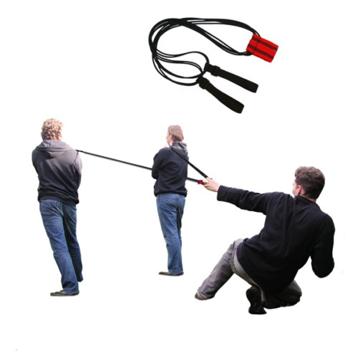
How will participants benefit? | The use of catapults can have applications across the curriculum including (but not limited to) history, D&T, science and maths.  General physical literacy will be developed by using simple activities.  Group working and social skills will be developed by participants, including turn taking and socially supporting each other.  Builds resilience and then confidence through success and challenge.  Fun, achievement and physical enjoyment of the activity.
Who will be at risk? | Staff  Participants (children and adults)  Passers by or observers

Possible hazards and risks: | Being in the firing line:  - being hit by a launched item  - being hit by catapult elastic itself when in front  Being hit with the catapult elastic when behind. This may happen if a ‘holder’ lets go, and the person pulling the catapult back or other people could be hit.  Being hit from in front of the catapult.  Strangulation.  A fixed mounting point pulling out, leading to bungee or mount colliding with someone at speed.  Equipment failure – either bungee, knot or stitching failing. This may lead to an unexpected release and someone being hit by recoiling catapult.
Local factors that may affect control measures or level of risk: | Group competence, local school guidelines.  Strength of grip of anyone involved in ‘drawing’ the catapult.  Strong winds (affecting direction of travel) or heavy rain (affecting grip strength)
Precautions and control measures to reduce the risk severity or likelihood: | Consider carefully what item is to be fired – always a soft item which will lose momentum, reducing possibility of harm  Have a firing line box beyond which no one must pass when catapults are being used. This should be highlighted to the group, likely (but not limited to) using features such as painted lines, edges of tarmac or a set of cones. If more than one catapult is used, they should be fired in the same direction and firing line, spaced at least 5m apart.  Catapults are not recommended for Early years students.- KS2 and above only is recommended.  Users need to stand firm, so that the person pulling the sling does not pull them over.  Users need to take care on first drawings, making sure anyone holding the catapult is able to maintain grip and stance.  Catapult should be visually inspected before use – Staff should satisfy themselves that either bought or ‘home made’ versions are in good condition.  Do not use fixed mounting points, only humans, this limits the potential energy of the projectile’s propulsion.

Precedents or comparisons: | Catapults can be found in STEM documentation, and engineering subjects advocate their use for teaching a variety of skills including critical thinking.  LtL has used ‘home made’ catapults from bungee or bike inner tubes for many years, without incident.
Judgement: | There are some risks when using the catapult, however making the group aware of the risks and using reasonable control measures (outlined above) reduces the likelihood of injury to equate to something similar in many sports that schools provide for pupils.  The use of catapults is a valuable and enjoyable experience that LtL supply, and encourage the use of, to many participants.

